**DAILY ONLINE ACTIVITIES SUMMARY**

|  |  |  |  |  |  |  |
| --- | --- | --- | --- | --- | --- | --- |
| **Date:** | | **09 June 2020** | | **Name:** | **KHATHEEJA SAFREENA.** | |
| **Sem & Sec** | | **4th sem, 2nd year** | | **USN:** | **4AL18CS037** | |
| **Online Test Summary** | | | | | | |
| **Subject** | **--------** | | | | | |
| **Max. Marks** | **-----** | | **Score** | | **-----** | |
| **Certification Course Summary** | | | | | | |
| **Course** | | **MARKETING FOUNDATION.** | | | | |
| **Certificate Provider** | | **Great Learning** | **Duration** | | | **5 hours** |
| **Coding Challenges** | | | | | | |
| **Problem Statement: 3 program** | | | | | | |
| **Status: Executed** | | | | | | |
| **Uploaded the report in Github** | | | **Yes** | | | |
| **If yes Repository name** | | | [http://shafreenasharief / lockdown-coding](http://shafreenasharief / lockdown-coding" \o "http://shafreenasharief / lockdown-coding)  [http://shafreenasharief / locked-down--certification-course](http://shafreenasharief / locked-down--certification-course" \o "http://shafreenasharief / locked-down--certification-course)  [http://shafreenasharief / Daily\_Report](http://shafreenasharief / Daily_Report" \o "http://shafreenasharief / Daily_Report) | | | |
| **Uploaded the report in slack** | | | **Yes** | | | |

Certification Course Details: (Attach the snapshot and briefly write the report for the same)

Coding Challenges Details: (Attach the snapshot and briefly write the report for the same)

**CERTIFICATION COURSE SUMMARY:**

Today I continued certificate course on **'MARKETING FOUNDATION',** through **GREAT LEARNING.**The course was scheduled for 5 hrs .I completed 2 modules that are Customer lifetime value,Customer Retention-2.I attempted quiz ,which gave me a clear veiw about the topics that were thought and discussed.It consists of 10 modules which also include assessments.

I successfully completed certification course on MARKETING FOUNDATION Through GREAT LEARNING.The course is secluded for 5 hour.I took up the final quiz.

**The concept covered in the course are as follows:**

* Introduction to Marketing.
* Marketing Mix.
* Plan Implementation.
* Marketing strategy.
* Product lifecycle.
* Customer value analysis.
* Satisfaction & loyalty.
* Customer lifetime value.
* Customer Retention-2.

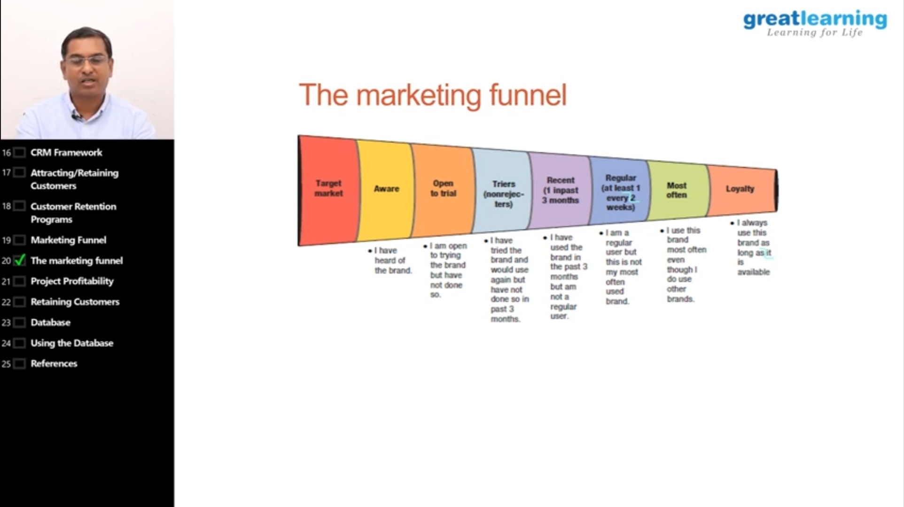

* **There is the snapshot of the certificate.**



**CODING CHALLENGE:**

Today I solved 3 coding challenge,

**Problem Statement 1:**

**1.**  **Write a C++ Program to rotate the matrix by K times Program in C**

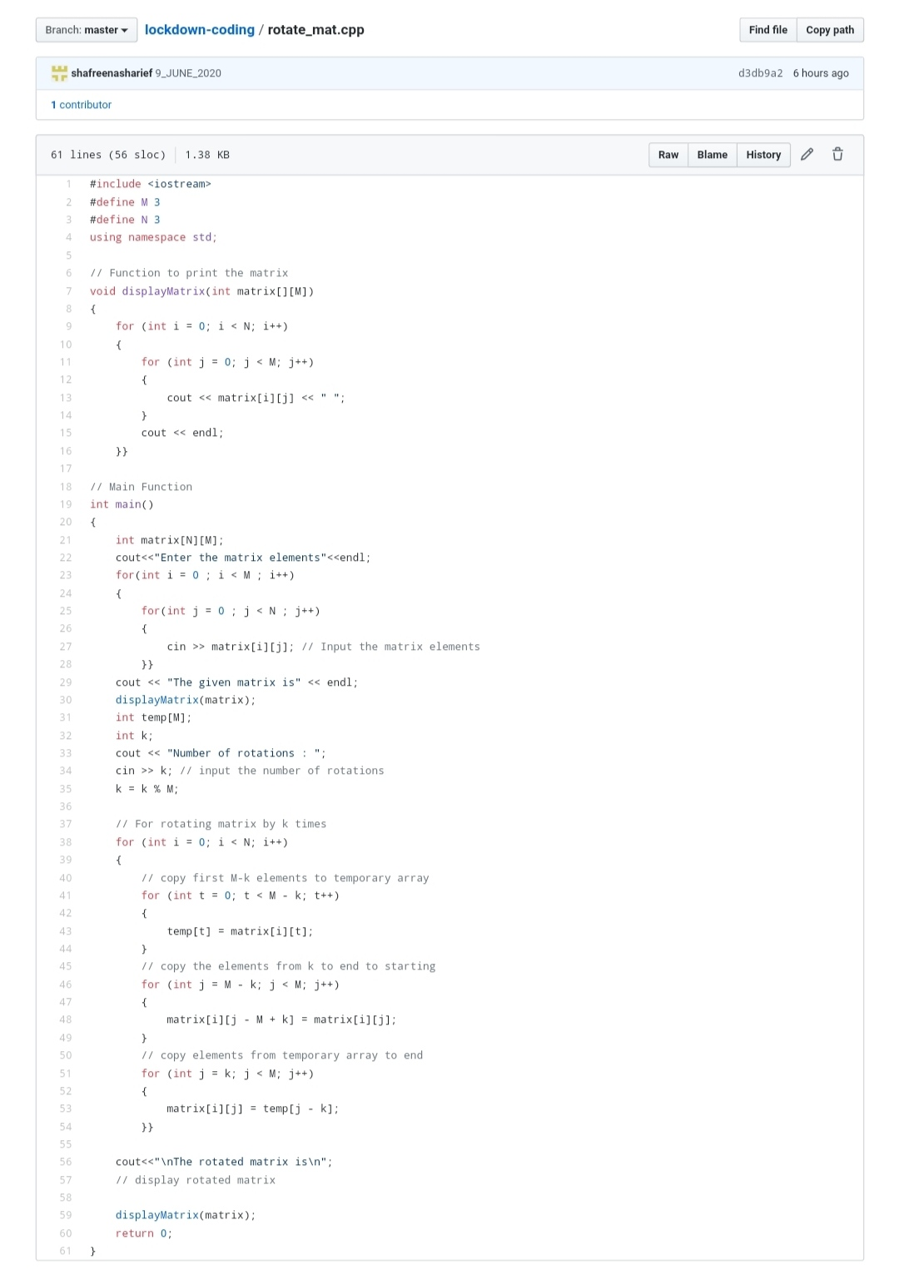

**Problem Statement 2:**

**Write a java program to count all the triplets such that sum of two elements equals the third element.**

Given an array of distinct integers. The task is to count all the triplets such that sum of two elements equals the third element.

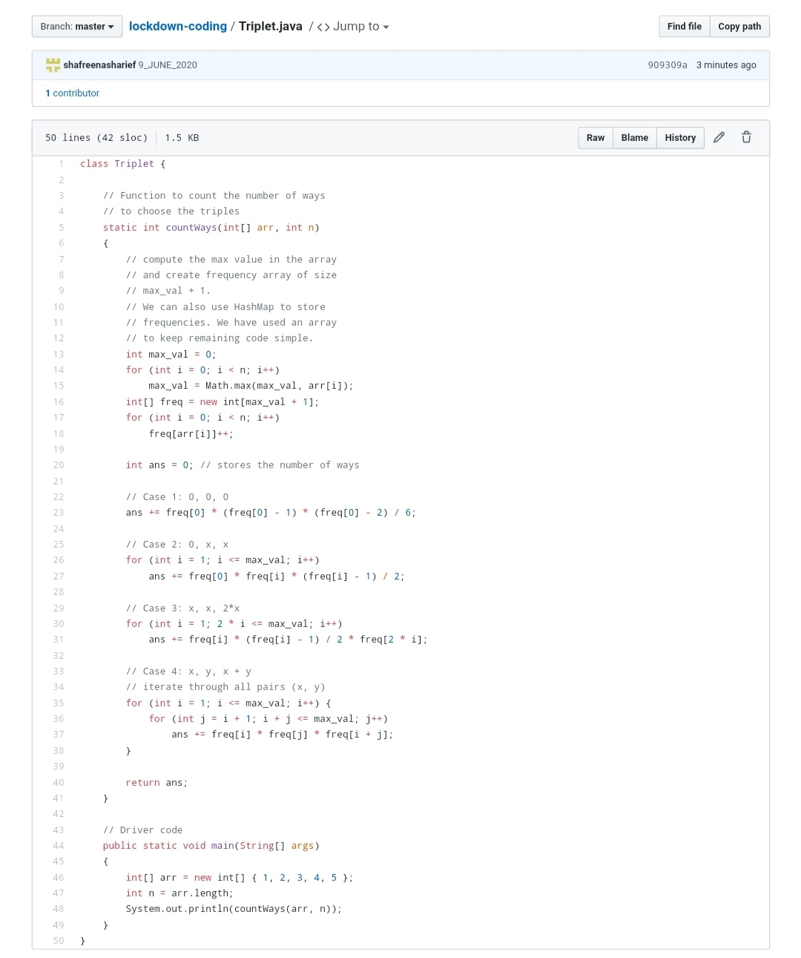

**Input**:  
The first line of input contains an integer T denoting the number of test cases. Then T test cases follow. Each test case consists of two lines. First line of each test case contains an Integer N denoting size of array and the second line contains N space separated elements.

**Output**:  
For each test case, print the count of all triplets, in new line. If no such triplets can form, print "-1".

**Constraints**:  
1 <= T <= 100  
3 <= N <= 105  
1 <= A[i] <= 106

**Example:**  
Input:  
4  
1 5 3 2

Output:  
2

Explanation:  
There are 2 triplets: 1 + 2 = 3 and 3 +2 = 5

**Problem Statement 3:**

Write a Java Program to find total number of subarrays which start and end with the same element.

Given an array A of size N where the array elements contain values from 1 to N with duplicates, the task is to find total number of subarrays which start and end with the same element.  
**Examples:**

Input: A[] = {1, 2, 1, 5, 2}  
Output: 7  
Explanation:  
Total 7 sub-array of the given array are {1}, {2}, {1}, {5}, {2}, {1, 2, 1} and {2, 1, 5, 2} are start and end with same element.

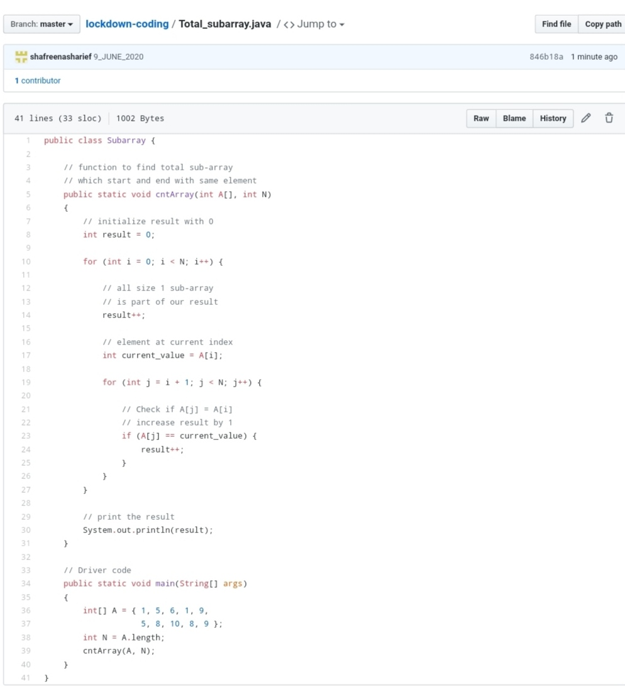

SOLUTION : I have uploaded the solution of the above 3 coding problems in my GitHub repository.

[http://shafreenasharief / lockdown-coding](http://shafreenasharief / lockdown-coding" \o "http://shafreenasharief / lockdown-coding)

[http://shafreenasharief / locked-down--certification-course](http://shafreenasharief / locked-down--certification-course" \o "http://shafreenasharief / locked-down--certification-course)

[http://shafreenasharief / Daily\_Report](http://shafreenasharief / Daily_Report" \o "http://shafreenasharief / Daily_Report)